CHAPTER 5: Separating mixtures
Worksheet 5.9

Single bubble maps and flowcharts
Science Quest 7: pages 204–205
Student: Class:

Think and create

1. The single bubble map below identifies some of the methods used to separate mixtures.
Add as many additional bubbles as you can. You are doing very well if you can fill 10 bubbles.

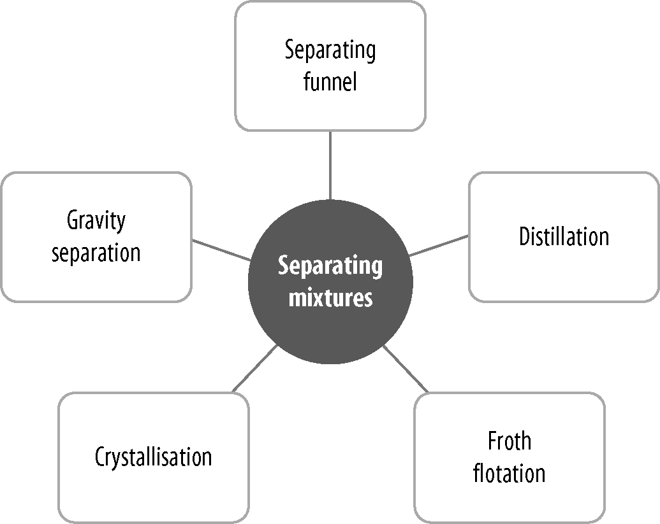
- Methods of separating mixtures
2. Complete the following flowchart to show how salt can be recovered from a mixture of salt and sand.

Step 1: Add water to the mixture and stir.

Step 2:

Step 3: Pour salty water into an evaporating dish.

3. Arrange the following steps in the correct order and complete the flowchart to show how country water supplies are purified.
● Water pumped from river to lake
● Alum added to water
● Water filtered through sand and gravel
● Floc settles to bottom to form a sediment
● Water pumped to local water tower

4. An unfortunate bush camper has accidentally mixed water with the kerosene that he needs to fuel his camp stove. Help him out by drawing a flowchart showing how to separate the water from the kerosene.
(Hint: Kerosene does not dissolve in water.)

